ROBIN HOOD INVITATIONAL
DIVING ORDER:

Meet Entry and Scoring Form
Please Print Clearly

Name of Diver: |  |  | Meet Date: |  | Event Number:
Club: | Division: |  | Diver’s Date of Birth: |  | Event Age Group:
Coach: |  |  | Meet Location: |  | Gender:
Instructions to Divers: 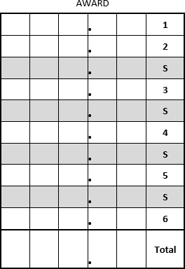
Order | Dive No. | Pos. | Dive Name: | DD: | Judge’s Scores |  |  |  |  | Net Total
 |  |  |  |  | 1 | 2 | 3 | 4 | 5
1
2
3
4
5
6

- Please fill out the information at the top of this form
- Enter diver number, position, name and degree of difficulty from the MCDL Table of Dives
- Be sure to sign your name below and Have Fun!
FINISH PLACE

Diver’s Signature Coaches Initials

